Test cases:

1. **Unconstrained Branin**

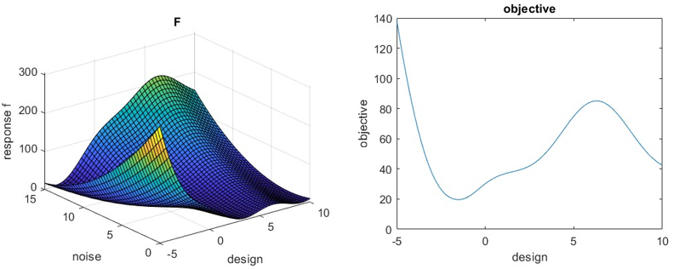

Unconstrained optimum of this example:

with objective function is at: with

with objective function is at: with

with objective function is at: with

This is the ground truth optimum using the actual function (not using a metamodel created by DOE)

1. **Branin with one inequality constraint**

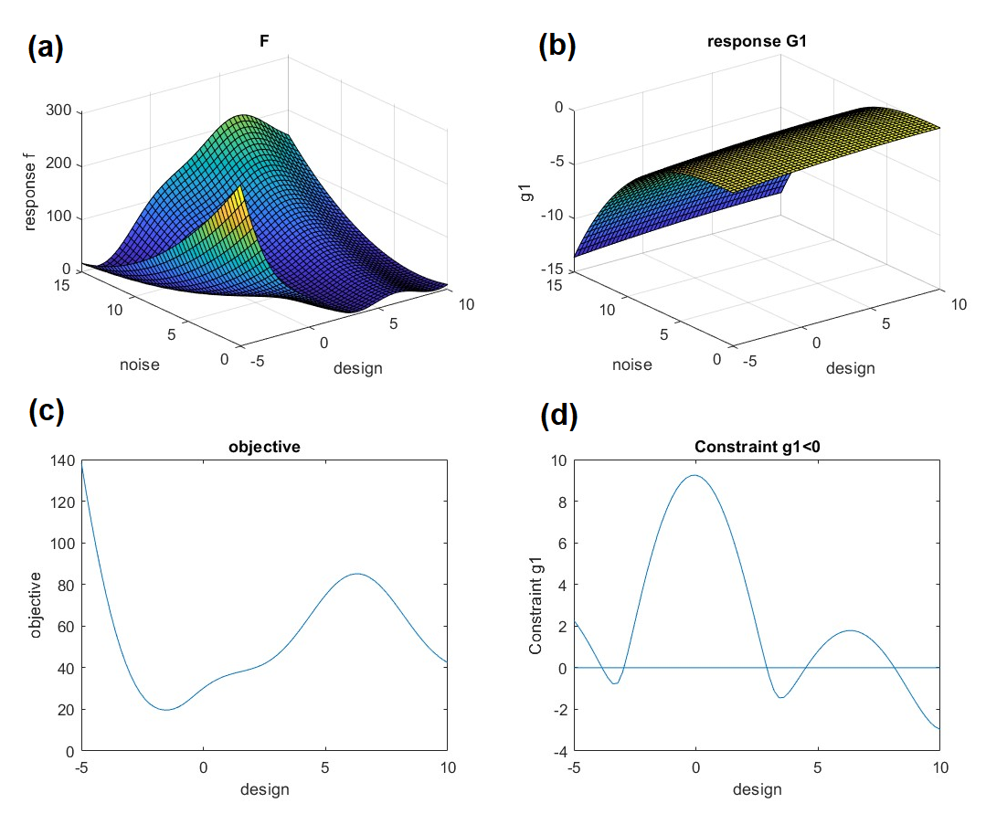

Figure 1: Branin function (a) and a constraint (b), objective function (c) and constraint function (d)

The ground truth optimum using the actual function (not using a metamodel created by DOE) is:

With objective function (c) and constraint function

at with

With objective function (c) and constraint function

at with 63.8640

(x=2.8981, obj=45.0198 is a local optimum which is not a correct answer)

**HARTMANN 6-DIMENSIONAL FUNCTION with no inequality constraint[1]**

**Unconstrained**

Hartmann has 6 input variables with 4 design and 2 noise.

Ranges of all variables are 0 and 1 therefore for noise mean=0.5 and st-dev=0.5/3=0.1666

|  |  |  |
| --- | --- | --- |
| DesignVar1 | 0 | 1 |
| DesignVar2 | 0 | 1 |
| DesignVar3 | 0 | 1 |
| DesignVar4 | 0 | 1 |
| NoiseVar1 | 0.5 | 0.166 |
| NoiseVar2 | 0.5 | 0.166 |

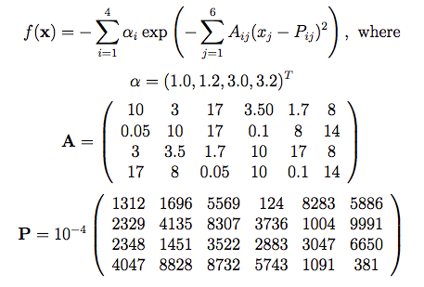

The ground truth optimum using the actual objective function (not using a metamodel created by DOE) with objective function is :

with objective function is :

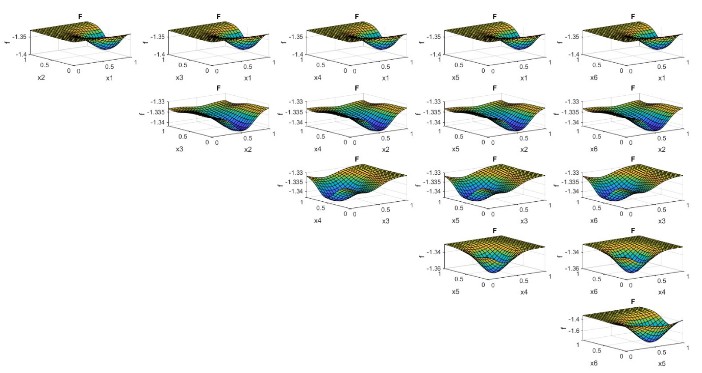

Figure 2: cross sections of Hartmann function

1. **HARTMANN 6-DIMENSIONAL FUNCTION with one inequality constraint**

Modified griewank function is used as a constraint:

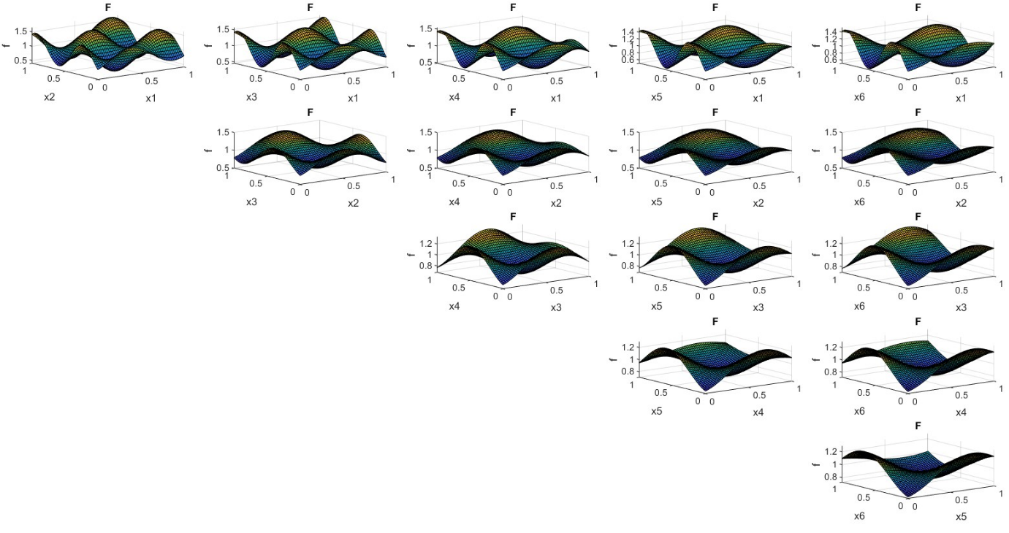

Figure 2: cross sections of griewank function with _9_1 scaling and shift

The ground truth optimum using the actual function (not using a metamodel created by DOE) is:

Objective is and constraint function is val=0.05

x= 0.1426 0.1640 0.5494 0.1587 obj= -1.7308

Objective is and constraint function is val=0.05

1. **HARTMANN 6-DIMENSIONAL FUNCTION with two inequality constraint**

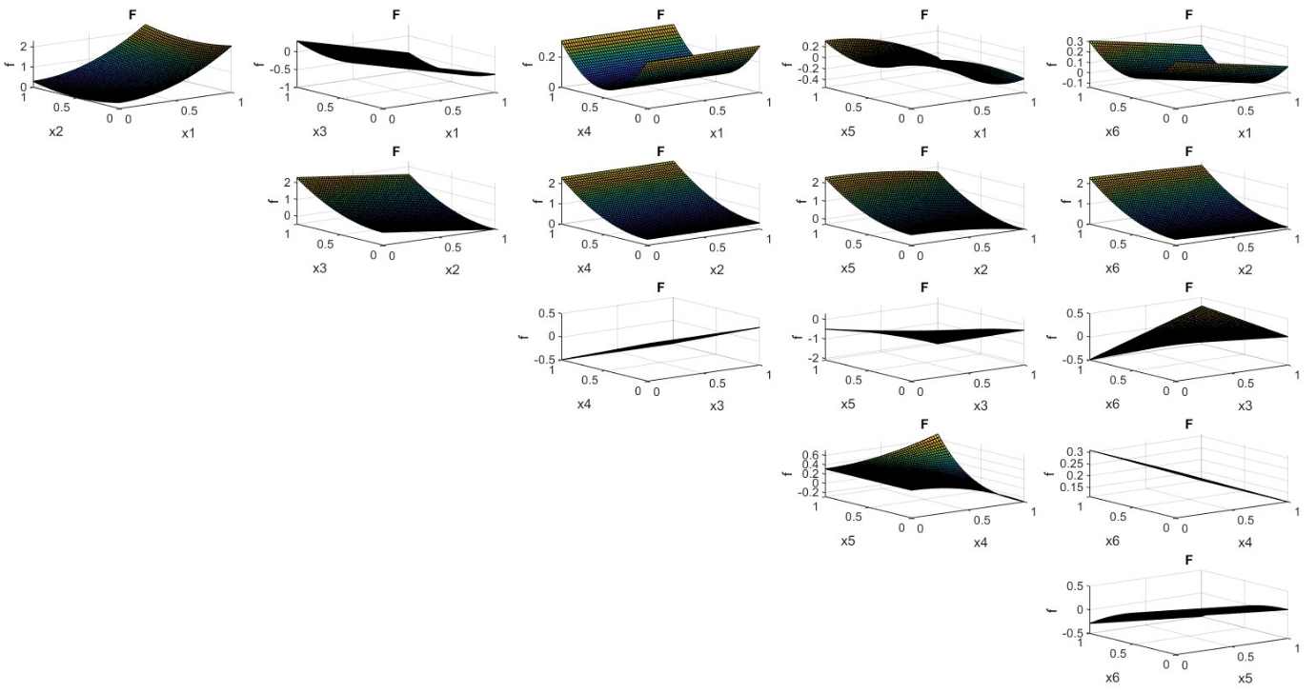

Figure 2: cross sections of g2 constraint function

Value =0.05 must be entered separately (Not like the previous examples for which the value was 0)

The ground truth optimum using the actual function (not using a metamodel created by DOE) is:

Objective and constraint functions val=0.05

Objective and constraint functions val=0.05

Objective and constraint functions val=0.05

1. https://www.sfu.ca/~ssurjano/hart6.html